

**Fall 2014**

ASPA Voice

First, I want to express my gratitude for the opportunity to serve you as conference chair. I hope this newsletter finds everyone settling back into the fresh, new school year! With the short summer I know we hardly had time to rest our brains before jumping back aboard. I wanted to give a brief update for some exciting events coming up.

Hopefully you have already registered for our fall conference, but if not, here’s the scoop. We will be hosting Dr. Eric Hartwig on September 25-26 at the Embassy Suites in Little Rock, AR. I’m sure by now you have received numerous emails with information regarding the content, but I wanted to reiterate the details. Dr. Hartwig received his doctorate in Educational Administration from the University of Wisconsin-Madison, a M.S. in School Psychology and a B.S. in Psychology from the University of Wisconsin-La Crosse. He is experienced and licensed as a Director of Pupil Services, District Administrator and a School Psychologist. Presently, he is the Administrator of Pupil Services for the Marathon County Children with Disabilities Education Board and is the author and principle trainer on the Just-in-Time: Behavioral Initiative Project. *continued pg. 3*

First and foremost I would like to say thank you for making me the President Elect for the 2014-2015 term. I am excited to work for you to increase awareness of the role and importance of School Psychology Professionals in Arkansas. It is my hope to advocate for you as professionals as we continue to advocate for the students, families, and teachers we serve. I have long believed that we play a unique and important role in the lives of those we work with. We have the opportunity to remove barriers students may face. These barriers may be educational, emotional, or environmental. Great strides have been made in our state to raise the awareness that a school psychology professional is of greater benefit than the typical testing role to which we are usually linked. I hope to continue to increase awareness so that we may use our training and abilities to help students succeed. I strongly believe that our role and education puts us in a unique position to bridge services for the variety of needs our students may have. My main goal is to continue to advocate for increased awareness of the skill set of School Psychology Professionals so that the true value of our potential contribution is realized. I look forward to working with the wonderful ASPA members across state. Please always feel free to contact me if there is anything I can do for you!

• Fall Conference Information

• President- Elect Address

***Individual Highlights:***

New ASU Staff 2

School-Wide Prevention 2

ASPA Fall Conference, Cont.

3 & 4

## Note from Kyla Warnick, ASPA President-Elect

Conference Corner

Dr. Gill Strait is an assistant professor in the School Psychology Program at Arkansas State University. He earned his Ph.D. in School Psychology from the University of South Carolina in 2011. He is an expert on School-based Motivational Interviewing and Mentoring. Dr. Strait has published 9 peer-reviewed articles pertaining to these topics. In addition to his research, Dr. Strait has three years of applied experience working in the schools. Specifically, Dr. Strait completed an APA-approved pre-doctoral internship in Dallas Independent School District, where he primarily provided evidence based cognitive-behavioral therapy to youth and their families. In addition, he completed a two-year post-doc in Saint Louis Special School District where he conducted psycho-educational assessments and provided consultation to schools on Response to Intervention. Recently at ASU, he has collaborated with undergraduate and graduate students to create the Rising Stars Program, which is a service-learning program that provides evidence-based and experimental academic and behavioral interventions to local schools.

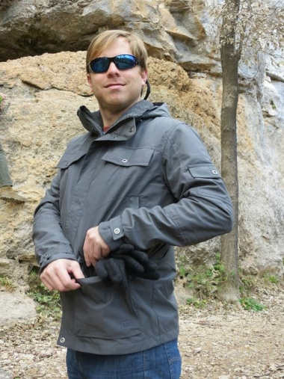

Prevention in the Schools:

Sample Programs and Roles for School Psychologists

**Schools: Sample Programs and Roles for School Psychologists**

For over 50 years, the triumvirate of professional roles typically performed by school psychologists has included assessment, consultation, and intervention. While these major roles have remained relatively constant, there are forces both internal and external to the professional itself that may influence the ways in which school psychologists use their skills to benefit children, families, and schools (Fagan & Wise, 2007). One such force is the inclusion of “Response to Intervention” (RtI) in the 2004 IDEA criteria for identifying children with specific learning disabilities.

The commonly accepted first tier of an RtI approach includes universal screening and preventative programming for all children to reduce the prevalence of academic and behavioral problems in the school setting. Another force is NASP’s recent “Model for Comprehensive and Integrated School Psychological Services,” which includes ten domains of professional practice. One of these domains, *Preventative and Responsive Services*, combines the traditional skills of consultation, problem solving, and intervention with (1) promoting the understanding of risk and protective factors that influence systemic problems such as school failure, bullying, and suicide and (2)

*continued pg. 5*

Joan B. Simon, Ph.D., Lenora Nunnley, Lauren McCoy, Keyoor Joshi

University of Central Arkansas

There is an increasing need for school psychologists to use their traditional skills of assessment, consultation, and intervention in the non-traditional roles of planning, implementing, and evaluating school-based prevention programs. To this end, five empirically-supported prevention programs were individually reviewed. Six major components of prevention programming and the ways school psychologists can contribute to each component are discussed.

**Prevention in the**

ASPA has gone social!

Find us on Facebook:  
[https://m.facebook.com/ profile.php?id=1503327889880673](https://m.facebook.com/%20profile.php?id=1503327889880673)

We are on Instagram:

[http://instagram.com/ arschoolpsych](http://instagram.com/%20%20arschoolpsych)

Twitter:  
@ARschoolpsych

Pinterest:  
search for ASPA under "Pinners"

## ASU Welcomes New Assistant Professor

Dr. Hartwig has done extensive research on discipline, school violence, psychoeducational assessment and related special education issues.

Dr. Hartwig has presented numerous times in Arkansas, but will be tailoring his presentation to meet the needs of those working with children with significant behavior problems. Dr. Hartwig will be presenting more in-depth and with greater detail than his previous presentations in the state. Specifically, Dr. Hartwig will provide a detailed presentation of Manifestation Determination (MD) including how and when do you document a manifestation determination?  Specific procedures for addressing the manifestation issue will be provided with key recommendations on how IEP Team members can respond to this often perplexing process.

Additionally, the process of conducting functional behavioral assessments (FBA) will be discussed. Dr. Hartwig will explain and explore the legal and practical requirements for addressing behavior problems of students.  How to conduct and document a seven-step functional behavior assessment with educational implications for programming will be shared. **Dr. Hartwig’s** presentation will also provide some practical, user-friendly techniques for capturing behavioral success using the perfect 10-step behavior plan.

Furthermore, this workshop will challenge the retrospective view that FBAs and MDs can only be used in after-the-fact analysis. Dr. Hartwig will demonstrate how these same processes can be used to gain a fuller understanding of a child’s needs and help shape behavioral competence with appropriate intervention. Dr. Eric Hartwig will show the audience how to use FBAs and MDs to help develop successful behavior interventions. You’ll learn how to:  
  
•    Use FBAs and MDs to understand what classroom behavior reveals about a student and the student’s responses to the contextual variables in the school environment.  
  
•    Glean intervention-ready information from the FBA’s comprehensive individualized approach to examining the variables that maintain challenging behaviors.  
  
•    Use the MD process to reveal key information about relationships between critical behavioral events and a student’s disability.  
  
•    Root your interventions in the identification of the consequences maintaining behavior and their associated stimulus controls.

**Dr. Hartwig will motivate us with his “Strange Days:  Confessions of an Aging Rock Star” presentation.** This presentation will discuss the very serious subject of implementation of education-from a not-so-serious point of view.  As an aging rock star turned educational psychologist, Dr. Hartwig will present a rumbling, relentless review of where we've been and where we're going in the field. With great humor, Dr. Hartwig will provide a lesson in how to reconnect to the reason we first became educators. Dr. Hartwig, in a surprising rock star performance, will present a relentless review of where we’ve been and where we’re going in education.

I will leave you with a sneak peek into next year’s fall conference. September 21 and September 22, 2015 we will return to the Embassy Suites in Little Rock to host Dr. Peg Dawson. Peg Dawson, Ed.D., received her doctorate in school/child clinical psychology from the University of Virginia. She worked as a school psychologist for 16 years in Maine and New Hampshire, and, for the past 20 years has worked  *continued pg. 4*

Dr. Eric Hartwig

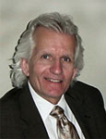

“As an aging rock star turned educational psychologist, Dr. Hartwig will present a rumbling, relentless review of where we've been and where we're going in the field.”

## Conference Corner, Continued

**Conference Corner, Continued**

the Center for Learning and Attention Disorders in Portsmouth, New Hampshire, where she specializes in the assessment of children and adults with learning and attention disorders. Along with her colleague, Dr. Richard Guare, she has authored several books, including a book for professionals, *Executive Skills in Children and Adolescents: A Practical Guide to Assessment and Intervention* (recently revised) as well as a book for parents, *Smart but Scattered*. Their most recent books are *Coaching Students with Executive Skills Deficits* and *Smart but Scattered Teens.* Dr. Dawson is a past president of both the National Association of School Psychologists and the International School Psychology Association. She is also the 2006 recipient of NASP’s Lifetime Achievement Award and a 2010 recipient of the International School Psychology Association Distinguished Services Award. Dr. Dawson will be conducting her workshop entitled “Smart but Scattered: Executive Dysfunction at Home and at School”.

**Session Description:** Youngsters with poor executive skills are disorganized or forgetful, have trouble getting started on tasks, get distracted easily, lose papers or assignments, forget to bring home the materials to complete homework or forget to hand homework in. They may rush through work or dawdle, they make careless mistakes that they fail to catch. They don’t know where to begin on long-term assignments, and they put the assignment off until the last minute, in part because they have trouble judging the magnitude of the task and how long it will take to complete it. Their workspaces are disorganized, and teachers may refer to their desks, backpacks, and notebooks as “black holes.” Students with executive skill deficits present tremendous challenges to both parents and teachers who often find themselves frustrated by children whose problems in school seem to have little to do with how smart they are or how easily they learn.

**Learning Objectives:** As a result of this workshop, participants will:

1. Understand executive skills within the context of brain development.
2. Be able to identify how executive skills impact school performance and daily living.
3. Have access to a repertoire of strategies to improve executive skills in students. These will include strategies to modify the environment to reduce the impact of weak executive skills and procedures such as coaching that can be used to teach children how to improve specific executive skill deficits in the context of home or school performance expectations.

Finally, I want to remind you that several opportunities throughout the school year are in the works. Watch your email closely for the latest updates and check the website frequently for new information. As I gaze ahead to the excitement that this school year brings, I look forward to seeing you all in a month to share exhilarating stories! I wish you all the best! And remember we always need additional hands and brains for the conference committee. Feel free to contact me anytime ([ghenwray@yahoo.com](mailto:ghenwray@yahoo.com)).

Blessings,

Gretchen Clayton

ASPA Conference Chair

[](http://www.smartbutscatteredkids.com/Books/listings)

2015 Fall Conference

September 21 & 22

**ASPA T-Shirts Available at the Fall Conference**

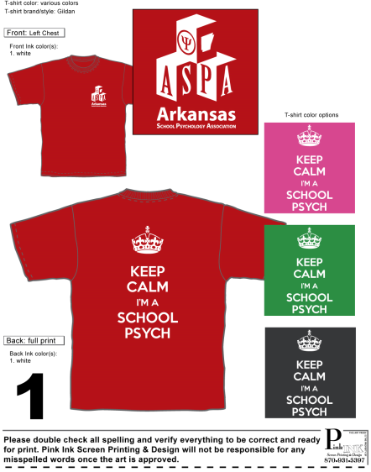 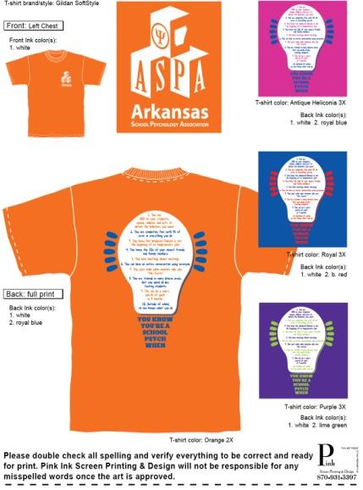

**Prevention Program, Continued**

assisting with the development, implementation, and evaluation of prevention programs (NASP, 2010).

There is evidence to suggest that some school psychologists are involved in preventative activities in the schools (e.g., prevention team membership, conducting suicide risk assessments, crisis intervention) (Brock, Nickerson, Reeves, & Jimerson, 2008; Debski, Spadafore, Jacob, Poole, & Hixon, 2007; Strein & Koehler, 2008). However, most school psychologists are not directly involved in school-wide preventative programming within their school districts (Bramlett, Murphy, Johnson, Wallingsford, & Hall, 2002). There are a variety of reasons why this is the case; two reasons are (1) limited knowledge of available research supported programs, and (2) limited understanding of how one can meaningfully contribute to such programs. To address the aforementioned reasons, this article will provide information on five empirically based prevention programs followed by a discussion of how school psychologists can meaningfully contribute to the planning, implementation, and/or evaluation of prevention programs. The prevention programs presented in this article, researched by graduate students as part of an introductory seminar course on school psychology at the University of Central Arkansas, are organized into five categories: improve school achievement, prevent school bullying, reduce school dropout, prevent suicide, and prevent school violence.

**School-Based Prevention Programs**

Nation et al. (2003) identified nine characteristics that are associated with effective prevention programs—comprehensive services, varied teaching methods, sufficient dosage, theory driven, positive relationships, appropriately timed, socio-culturally relevant, outcome evaluation, and well-trained staff. Many of the aforementioned characteristics are evident in the prevention programs presented in this article. For example, four of the five programs are universal level prevention programs which comprehensively address school wide needs. Most of the programs are also implemented during the elementary school years (i.e., appropriately timed) and are of sufficient duration to engender positive change. Information on each of the five programs is included in Table 1, along with details about each program’s training requirements, costs, and selected research support. The following descriptions of the prevention programs supplement the information provided in Table 1. Additional references for each program are provided in the Appendix.

**Improve School Achievement**

*Lions Quest (LQ)* is a universal prevention program, for Kindergarten through 12th graders, whose mission is “to empower and support adults throughout the world to nurture caring and responsibility in young people” (Lions Quest, 2012). Each of the three LQ programs—Skills for Growing (K-5th grade), Skills for Adolescence (6-8th grade), and Skills for Action (9-12th grade)—include components related to school curriculum, service-learning, positive school climate, family involvement, and community involvement. “Skills for Growing” consists of 24-27 lessons per grade level that may be taught once per week. It is recommended that “Skills for Adolescence” be implemented as a three-year program in which lessons are taught at least twice a week. “Skills for Actions” consists of 33 lessons that can be taught in as little as one semester or as long as a four-year period. Materials include a curriculum kit containing 102 lessons, a student workbook, a parent book, a parent meeting guide, and tests for evaluation of each unit.

**Prevent School Bullying**

The *Olweus Bullying Prevention Program (OBPP)* is a comprehensive, school-wide program for 3rd through 12th grade students designed to (1) reduce bullying problems among students (2) prevent new bullying problems, and (3) improve peer relations at school. OBPP includes intervention at four levels: school, individual, classroom, and community. Participating schools establish a Bullying Prevention Coordinating Committee (BPCC) whose members are trained by a professional Olweus Trainer. The BPCC organizes the administration of Olweus Bullying Questionnaires to students and develops a plan for school-wide implementation of the program. Anti-bullying messages are consistently reinforced by the actions of all teachers and staff and through the development of school rules. An important part of the OBPP is developing partnerships with community members and organizations to help spread anti-bullying messages. The School-wide Guides and Teacher Guides include a CD-ROM and DVD. OBPP has been named an Effective Program by the U.S. Department of Education and is supported by extensive world-wide research.

**Reduce School Dropout**

*Check & Connect* is a selective dropout prevention program for Kindergarten through 12th grade students that uses adult mentors to (1) promote students’ engagement with school and (2) reduce school dropout. Mentors are typically full-time employees who are guided by the program’s implementation manual to work with students over a period of at least two years. Specifically, mentors “check” on students by monitoring their attendance, school engagement, and grades; and “connect” with students by partnering with students, families, community providers, and school personnel (Check & Connect Student Engagement Model, 2012).

**Prevent Suicide**

*Signs of Suicide (SOS),* a school-wide prevention program for 5th through 12th grade students, is designed to educate students and parents about how to respond to the signs of depression and suicide while providing resources for students who experience them. Students are taught the signs of depression and an acronym to remember the steps of a proper response (ACT – Acknowledge, Care, Tell) when the signs are noticed. The SOS Kit for middle school (5th-8th grade) consists of an implementation guide, an educational DVD and discussion guide, parent and student newsletters, self-injury packets, and additional resources (e.g., stickers and posters). The SOS Kit for high school (9th- 12th grade) consists of an implementation guide, an educational DVD and discussion guide, a training DVD for staff, the Brief Screen for Adolescent Depression (BSAD) tool, high school student newsletters, and additional resources (e.g., wallet cards, and posters). Both kits provide materials for 300 youth, parents, and school staff (Screening for Mental Health, 2010).

**Prevent School Violence**

*Responding in Peaceful and Positive Ways (RIPP)* is a school-based violence prevention program for middle school students (SAMHSA, 2007) grades 6th through 8th. The three components of the program are (1) environmental (non-violent conflict resolution and peer support), (2) intrapersonal (diminish stereotypes, falsehoods, and contributors to violence) and (3) behavioral (structures problem solving and conflict resolution skills). The current curriculum includes 16 lessons per grade level that are taught over the course of one school year and student handouts are available in both English and Spanish.

**Implications for School Psychologists**

As stated in the introduction, school psychologists can meaningfully contribute to the planning, implementation, and/or evaluation of prevention programs. According to Strein and Koehler (2008), many of the skills needed for implementation of prevention programs are within the competencies already held by school psychologists. These authors presented six major components of prevention programming that will be used here to discuss the ways in which school psychologists can expand their professional role to include prevention activities.

The first component of prevention programming is *planning and selecting a prevention strategy or program*. School psychologists can contribute in many ways at this stage of prevention programming. For example, they can assist in conducting a needs assessment within a school to determine what type of program might be most appropriate for the building (Branden-Muller & Elias, 1991; Diamanduros, Downs, & Jenkins, 2008; Strein & Koehler, 2008). They can also assist in assessing a program’s research support, social acceptability, potential cost benefits, and grant writing for program support (Herman, Merrell, Reinke, & Tucker, 2004; Larson, 2008; Nastasi, 2000).

The second component of prevention programming is about understanding and addressing *issues related to diversity*. NASP has long promoted knowledge and skills in the area of understanding diversity issues and provision of effective professional services for those from diverse backgrounds, characteristics, and cultures (NASP, 2010). Thus, school psychologists should be well suited to help school staff members consider how a program will be accepted by those affiliated with the school and the broader community.

The third component of prevention programming, *program implementation*, requires both the skills of a leadership team and the ongoing assessment of treatment integrity. School psychologists are often integral members of school based teams and would be in a great position to be a member, or possibly a leader, of a team in charge of the organization and facilitation of a prevention program (Felix & Furlong, 2008; Larson, 2008). Further, school psychologists recognize the value of assessing treatment integrity and can contribute meaningfully to this part of the process (Larson, 2008).

The fourth component, sometimes mistakenly viewed as the final component, is *evaluation*. According to NASP, school psychologists should be versed in measurement, statistics, and research design. These skills are ideal for assisting in the many phases of program evaluation – from designing an evaluation plan (formative and/or summative) to collecting, analyzing, and disseminating the results (Brock et al., 2008; Nastasi, 2000).

The final two components of prevention programming are *institutionalizing the program* and *overcoming obstacles*. It is during these stages that a school moves from viewing a prevention program as a “time-limited project” to a part of the long term operation of the school (Strein & Koehler, 2008). While such a commitment might be outside the purview of the school psychologist, he/she can serve an advocacy role in promoting long-term adoption of a successful program.

In conclusion, there are multiple ways for school psychologists to use their current skills to play a vital role in the identification, implementation, evaluation, and institutionalization of school-based prevention programs. If school psychologists are willing and able, their strong foundation of skills in the areas of assessment, consultation, and intervention, that are most frequently used to benefit children one at a time, can be used more broadly in prevention activities to benefit children one class, one school, or one district at a time.

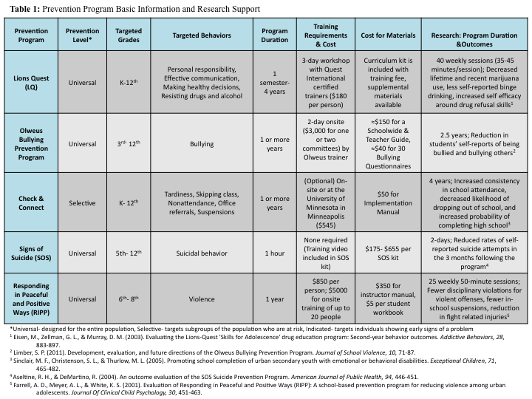

Acknowledgment: The authors would like to acknowledge the contributions of the following UCA students, in alphabetical order, to this article: Ashley Allred, Micah Baker, Sherese Hicks, Brenna Pardieck, Danielle Reece, David Walton, Michael Watson, and Mara Whiteside.

**References**

Bramlett, R. K., Murphy, J. J., Johnson, J., Wallingsford, L., & Hall, J. D. (2002). Contemporary practices in school psychology: A national survey of roles and referral problems. *Psychology in the Schools*, *39*, 327-335.

Branden-Muller, L. R., & Elias, M. J. (1991). Catalyzing primary prevention revolution in the school: The role of school psychologists. *Journal of Educational and Psychological Consultation*, *2*, 73-88.

Brock, S. E., Nickerson, A. B., Reeves, M. A., & Jimerson, S. R. (2008). Best practices for

school psychologists as members of crisis teams: The PREPaRE model. In A. Thomas, & J. Grimes, *Best Practices in School Psychology (5th Ed.)* (pp. 1487-1504). Bethesda MD: National Association of School Psychologists.

Check & Connect Student Engagement Model. (2012). *Check & Connect: A comprehensive student engagement intervention.* Retrieved on October 6, 2012, from http://www.checkandconnect.org

Debski, J., Spadafore, C. D., Jacob, S., Poole, D. A., & Hixon, M. D. (2007). Sucide intervention: Training, roles and knowledge of school psychologists. *Psychology in the Schools*, *44*, 157-170.

Diamanduros, T., Downs, E., & Jenkins, S. (2008). The role of school psychologists in the assessment, prevention, and intervention of cyberbullying. *Psychology in the Schools,*  *45*, 693-704.

Fagan, T. K., & Wise, P. S. (2007). *School psychology, past present and future (3rd ed.).*

Bethesda, MD: National Association of School Psychologists.

Felix, E., & Furlong, M. (2008). Best practices in bullying prevention. In A. Thomas & J.

Grimes (Eds.), *Best Practices in School Psychology (5th ed.)* (pp. 1279-1289). Bethesda, MD: National Association of School Psychologists.

Herman, K. C., Merrell, K. W., Reinke, W. M., & Tucker, C. M. (2004). The role of school psychology in preventing depression. *Psychology in the Schools*, *41*, 763-775.

Larson, J. (2008). Best practices in school violence prevention. In A. Thomas & J.

Grimes (Eds.), *Best Practices in School Psychology (5th ed.)* (pp. 1291-1307). Bethesda, MD: National Association of School Psychologists.

Lions Quest (2012). *Our Mission.* Retrieved October 29, 2012, from http://www.lions-quest.org/mission.php

Nastasi, B. K. (2000). School psychologists as health-care providers in the 21st century:

Conceptual framework, professional identity, and professional practice. *School*

*Psychology Review*, *29*, 540-554.

Nation, M., Crusto, C., Wandersman, A., Kumpfer, K.L., Seybolt, D., Morrissey-Kane, E., & Davino, K. (2003). What works in prevention: Principles of effective prevention programs. *American Psychologist, 58*, 449-456.

National Association of School Psychologists (2010). *Model for comprehensive and integrated*

*school psychological services*. Retrieved on October 29, 2012, from http://www.nasponline.org/standards/2010standards/2_PracticeModel.pdf

Screening for Mental Health. (2010). *FAQs: Signs of Suicide Program.* Retrieved on October 6, 2012, from <http://www.mentalhealthscreening.org/programs/youth-prevention-programs/sos/faqs.aspx>

Substance Abuse and Mental Health Services Administration’s National Registry of Evidence-based Programs (2007). *Intervention Summary: Responding in Peaceful and Positive Ways*. Retrieved on October 29, 2012 from

http://nrepp.samhsa.gov/ViewIntervention.aspx?id=59#Study 1

Strein, W., & Koehler, J. (2008). Best Practices in Developing Prevention Strategies for School Psychology Practice. In A. Thomas, & J. Grimes, *Best Practices in School Psychology (5th Ed.)* (pp. 1309-1322). Bethesda MD: The National Association of School Psychologists.

**Appendix**

**Lions Quest**

**Website:** [www.lions-quest.org/index.php](http://www.lions-quest.org/index.php)

**Additional References:**

Eisen, M., Zellman, G. L., & Murray, D. M. (2003). Evaluating the Lions-Quest 'Skills for Adolescence' drug education program: Second-year behavior outcomes. *Addictive Behaviors*, *28*, 883-897.

Laird, M. (2009). An evaluation report of student attitude and behavior changes to the Tennessee Department of Education and Volunteer Tennessee on the Learn and Serve America school-Based program. Retrieved on October 29, 2012, from [www.lions-quest.org/pdfs/EvaluationReportofStudentAttitude.pdf](http://www.lions-quest.org/pdfs/EvaluationReportofStudentAttitude.pdf)

Laird, M., & Syropoulos, M. (1995). An evaluation of Lions-Quest's Skills for Adolescence. Unpublished report.

Lions Quest. (2012). *Our Mission.* Retrieved on October 6, 2012, from http://www.lions-quest.org/mission.php

Sprunger, B., & Pellaux, D. (1989). Skills for adolescence: Experience with the international Lions-Quest program. *Crisis: The Journal of Crisis Intervention and Suicide Prevention*, *10*, 88-104.

**Olweus Bullying Prevention Program**

**Website:** www.olweus.org/public/index.page

**Additional References:**

Bauer, N. S., Lozano, P., & Rivara, F. P. (2007). The effectiveness of the Olweus Bullying Prevention Program in public middle schools: A controlled trial. *Journal of Adolescent Health*, *40*, 266-274.

Black, S. A., & Jackson, E. (2007). Using bullying incident density to evaluate the

Olweus Bullying Prevention Programme. *School Psychology International*, *28*, 623-638.

Olweus, D., & Limber, S. P. (2010). Bullying in school: Evaluation and dissemination of the Olweus Bullying Prevention Program. *American Journal of Orthopsychiatry*, *80*, 124-134.

**Check & Connect**

**Website:** [www.checkandconnect.org](http://www.checkandconnect.org)

**Additional References:**

Alvarez, M. E., & Anderson-Ketchmark, C. (2010). Review of an evidence-based school social work intervention: Check & Connect. *Children & Schools*, *32*, 125-127.

Sinclair, M.F., Christenson, S.L., Evelo, D.L., & Hurley, C.M. (1998). Dropout prevention for youth with disabilities: Efficacy of a sustained school engagement procedure. *Exceptional Children*, *65*, 7-21.

Sinclair, M. F., Christenson, S. L., Lehr, C. A., & Anderson, A. (2003). Facilitating student engagement: Lessons learned from Check & Connect longitudinal studies. *California School Psychologist*, *8*, 29-41.

Sinclair, M.F., Christenson, S.L., & Thurlow, M.L. (2005). Promoting school completion of urban secondary youth with emotional or behavioral disabilities. *Exceptional Children*, *71*, 465-482.

**Signs of Suicide**

**Website:** <http://mentalhealthscreening.org/programs/youth-prevention-programs/sos/>

**Additional References:**

Aseltine, R. H. (2003). An evaluation of a school based suicide prevention program. *Adolescent & Family Health*, *3*, 81-88.

Aseltine, R. H., & DeMartino, R. (2004). An outcome evaluation of the SOS suicide prevention program. *American Journal of Public Health, 94*, 446-451.

Gianesin, J. R. (2010). Tier 1 case example: Signs of Suicide (SOS). In J. P. Clark, M. Alvarez (Eds.), *Response to intervention: A guide for school social workers* (pp. 70-81). New York, NY US: Oxford University Press.

**Responding in Peaceful and Positive Ways**

**Website:** www.preventionopportunities.com/ripp.html

**Additional References:**

Farrell, A. D., Meyer, A. L., Kung, E. M., & Sullivan, T. N. (2001). Development and evaluation

of school-based violence prevention programs. *Journal of Clinical Child Psychology, 30,*

207–220.

Farrell, A. D., Meyer, A. L., Sullivan, T. N., & Kung, E. M. (2003). Evaluation of the Responding in Peaceful and Positive Ways (RIPP) seventh grade violence prevention curriculum. *Journal of Child and Family Studies*, *12*, 101-120.

Farrell, A. D., Meyer, A. L., & White, K.S. (2001). Evaluation of responding in peaceful and positive ways (RIPP): A school based prevention program from reducing violence among urban adolescents. *Journal of Clinical Child Psychology,* *30*, 451-463.

Farrell, A. D., Valois, R. F., Meyer, A. L., & Tidwell, R. P. (2003). Impact of the RIPP violence prevention program on rural middle school students. *The Journal of Primary Prevention*, *24*, 143-167.

# Wanted: ASPA Involvement

School Psychology Specialist: Are you interested in becoming involved in shaping the future of school psychology in Arkansas? You are invited to attend the next Arkansas School Psychology Board Meeting on Wednesday, September 24th from 5:00 to 7:00 pm at Mimi’s Café in Little Rock. The address is 11725 Chenal Parkway, Little Rock, 72211. Some topics of interest include future ASPA conferences, pursing a lobbyist to implement a SPS to student ratio and information about local School Psychology groups. If you are interested in attending, please contact Gretchen Clayton or Krystal Lovell to ensure we have a large enough meeting room. If you cannot attend, but would like to be invloved, please contact a board member to discuss small and large ways to be involved with ASPA. Vacancies this spring will include NASP Delegate and President-Elect. You can also be involved in regional meetings and trainings. Contact your regional representative to find out more about meetings held in your area throughout the year.

|  |  |  |
| --- | --- | --- |
| President | Carol Brown | [carol.brown@valleyviewschools.net](mailto:carol.brown@valleyviewschools.net) |
| Immediate Past President | Mary Bryant | [mbryant@crmail.k12.ar.us](mailto:mbryant@crmail.k12.ar.us) |
| President-Elect | Kyla Warnick | [kyla-e@hotmail.com](mailto:lpruitt@westsideschools.org) |
| Secretary | Lacey Monroe | [Lacey.monroe@gmail.com](mailto:Lacey.monroe@gmail.com) |
| Treasurer | Sue Featherston  Sharon Adams | [sfeatherston@almasd.net](mailto:sfeatherston@almasd.net)  [sharonhadams@hotmail.com](mailto:sharonhadams@hotmail.com) |
| NASP Delegate | Wendy Stovall | [wstovall@crmail.k12.ar.us](mailto:wstovall@crmail.k12.ar.us) |
| Student Representative (ASU) | Kory O’Brien | [koryobrien09@gmail.com](mailto:koryobrien09@gmail.com) |
| Student Representative (UCA) | Paula Burr | [paulaburr21@gmail.com](mailto:paulaburr21@gmail.com) |
| University Representative (ASU) | John Hall | [jhall@astate.edu](mailto:jhall@astate.edu) |
| University Representative (UCA) | Joan Simon | [jsimon@uca.edu](mailto:jsimon@uca.edu) |
| Conference Committee | Gretchen Clayton | [ghenwray@yahoo.com](mailto:ghenwray@yahoo.com) |
| Legislative Committee  NASP SPAN Contact | Rita Phillips | [lrwphilips@yahoo.com](mailto:lrwphilips@yahoo.com) |
| Membership/Public Relations | Krystal Lovell | [krystal0212@gmail.com](mailto:krystal0212@gmail.com) |
| Nominations/Elections/Awards | Beth McHenry | [bmc870@yahoo.com](mailto:bmc870@yahoo.com) |
| Publications | Charity Burdess  Carmen Chamberlain | [cburdess@rps.k12.ar.us](mailto:cburdess@rps.k12.ar.us) |
| Technology | Tammy Hagood  Elizabeth Spann | [Tammy.hagood@smail.astate.edu](mailto:Tammy.hagood@smail.astate.edu)  [spanne@nlrsd.org](mailto:spanne@nlrsd.org) |
| State Department Liaison |  |  |
| ESL/Bilingual School Psychology | Maria Lopez-Boysen | [flbmaria@gmail.com](mailto:flbmaria@gmail.com) |
| Central Region | Jamie Ristaino | [ristainoj@nlrsd.org](mailto:ristainoj@nlrsd.org) |
| North East Region | Linda Graham | [lgraham@nettletonschools.net](mailto:lgraham@nettletonschools.net) |
| North West Region | Charity Burdess | [cburdess@rps.k12.ar.us](mailto:cburdess@rps.k12.ar.us) |
| South East Region | Mickey Shell | [mkshell@earthlink.net](mailto:mkshell@earthlink.net) |
| South West Region | Beth McHenry | [bmc870@yahoo.com](mailto:bmc870@yahoo.com) |